Lab Program 1:

Develop a Java program that prints all real solutions to the quadratic equation ax2+bx+c = 0. Read in a, b, c and use the quadratic formula. If the discriminate b2 -4ac is negative, display a message stating that there are no real solutions.

SOURCE CODE:

import java.util.\*;

import java.lang.\*;

class box

{

public static void main (String args[])

{

System.out.println("Enter the coefficients of quadrartic equation");

Scanner sc= new Scanner(System.in);

double a=sc.nextDouble();

double b=sc.nextDouble();

double c=sc.nextDouble();

double d=(b\*b)-(4\*a\*c);

double r1;

double r2;

if(d>0)

{

r1=(-b+Math.sqrt(d))/(2\*a);

r2=(-b-Math.sqrt(d))/(2\*a);

System.out.println("Roots are real and distinct");

System.out.println("The roots are r1="+r1+""+"and r2="+r2);

}

else if(d==0)

{

r1=r2=(-b)/(2\*a);

System.out.println("Roots are real and same");

System.out.println("The roots are r1=r2="+""+r1);

}

else

{

r1=(-b)/(2\*a);

r2=(Math.sqrt(-d))/(2\*a);

System.out.println("Roots are imaginary and distinct");

System.out.println("The roots are r1="+r1+"+i"+r2);

System.out.println("The roots are r2="+r1+"-i"+r2);

}

}

}

WRITTEN CODE:

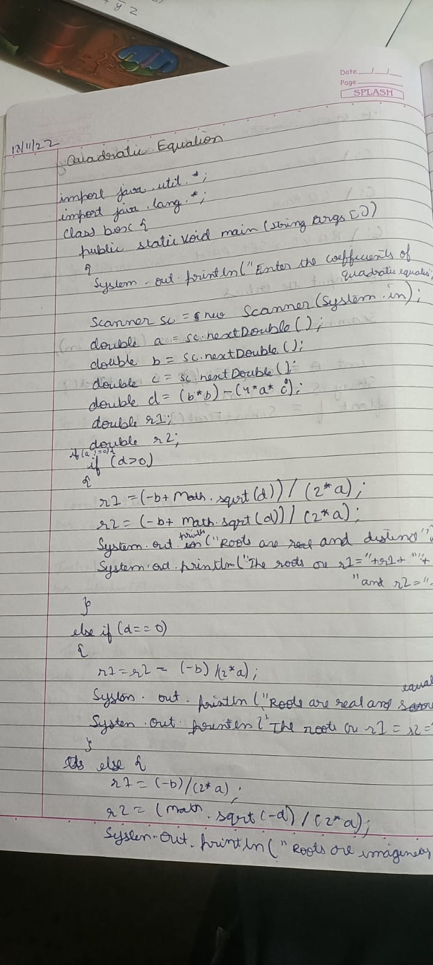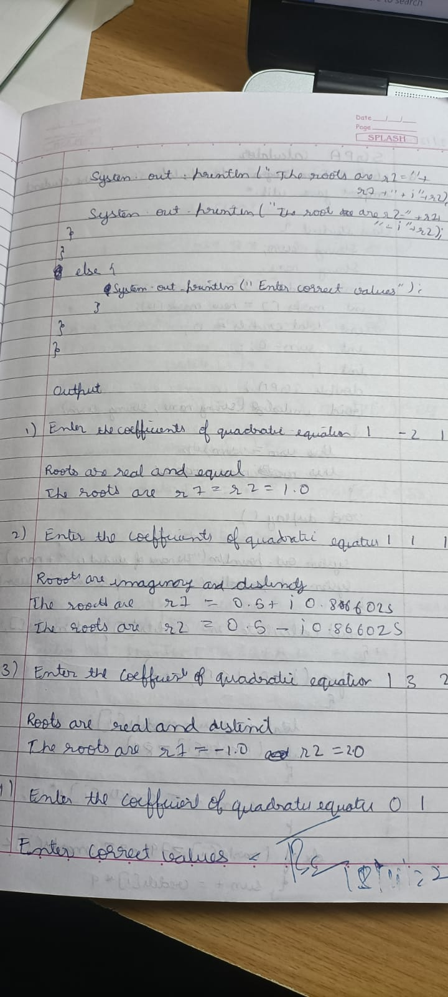

OUTPUT (including test cases):

